ELECTRONIC CIRCUITS AND DEVICES
ELEE 3455
LECTURE NOTES - DAVE SHATTUCK
SET #6

Chapter 5 -- INTRODUCTION TO BIPOLAR JUNCTION TRANSISTORS (BJTs)
also known as Junction Transistors, sometimes just as Transistors.
These are made up of two pn junctions back-to-back. There are two kinds of BJT, npn and pnp.

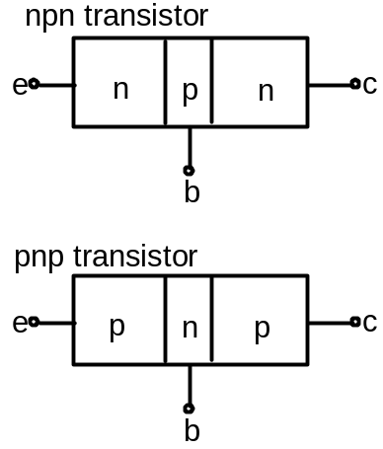

Where e = emitter
b = base
c = collector

The schematic symbols are:
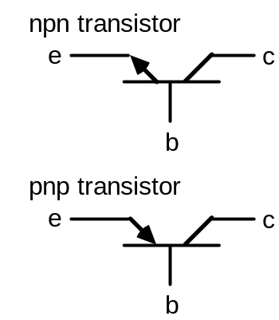

Mnemonic device: the arrows in these symbols point to the n region. The same thing happened with the diode.

We have four possible modes of operation of the BJT. They correspond to the two possibilities for the diode, which were forward biased ("on") and reverse biased ("off"). We will think about the transistor as being in one of these four modes, again based on the polarities of the voltages across the junctions. We will refer to the emitter-base junction (e-b) and the collector-base junction (c-b) in the table that follows.

Mode e-b jct. c-b jct. Use
Active forward reverse amplifier
Cutoff reverse reverse switch, off pos.
Saturation forward forward switch, on pos.
Reverse Active reverse forward special apps.

The Hambley text calls Reverse Active the Inverted Mode or Reverse Mode. After briefly mentioning it on page 186, it then ignores it. I only mention it here for completeness, and we will use it only much later with digital applications, specifically in TTL circuits. Its behavior is similar to that in the active region. We will ignore it also, for the time being.

Now I would like to consider the behavior of the transistor in one of the regions. I will pick the active region for this, since the behavior there will be typical of the way we use transistors.
Assume that I have forward biased the b-e junction, and reverse biased the b-c jct.

The forward bias of the b-e junction:
a) favors the flow of majority carriers in the base into the emitter, and
b) favors the flow of majority carriers in the emitter into the base.

The reverse bias of the b-c junction:
c) hampers the flow of majority carriers in the base into the collector, and
d) hampers the flow of majority carriers in the collector into the base.

No news here. But, remember as well that the reverse bias of the b-c junction:
e) favors the flow of minority carriers in the base into the collector, and
f) favors the flow of minority carriers in the collector into the base.

The key item, and the one that we are going to emphasize is e). Even though we think of reverse bias as the case with no current flow, that case holds only for majority carriers. The reverse bias favors the flow of minority carriers, and would result in significant current if only there were more minority carriers around.
This is exactly what is happening in the base. There are lots and lots of minority carriers (as viewed by the base) arriving from the emitter (where they were majority carriers). We think of them being injected by the emitter into the base, where a large proportion of them are swept into the collector.

Now, we have "lots and lots" of charge carriers moving. What determines how many of these charge carriers are moving? That is mostly determined by the base-emitter junction characteristics (voltage and current).

By being careful in how we build the transistor, we can make the current in the base connector (base current) small compared to the other currents (emitter current and collector current).

If we do this, we can see that a small quantity (base current) can be used to control a larger quantity (collector current). This is an amplifier.

Remember the Lake Erie model of the amplifier? I am now going to introduce the grad student model for the BJT amplifier. There are three assumptions needed for this model:
1) Grad students like beer.
2) Carling Black Label beer is not the most desirable brand of beer available.
3) Moosehead beer is a much more desirable brand of beer than Carling Black Label beer.

Demonstrate the grad student model for the BJT.

Please note: I am not advocating the consumption of alcohol. It is not necessary to consume alcohol to use this model. This model work just as well with Sharp's NA beer and Claustholer's NA beer. Be careful. Don't drink and derive.

Standard current polarities:
We will assume current polarities for a transistor, based on whether it is an npn or pnp transistor.
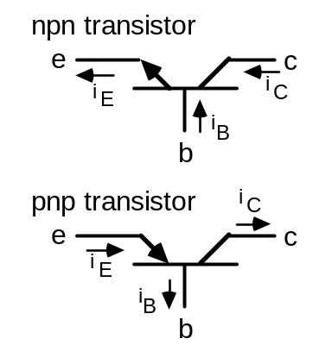

Transistor Characteristic Curves
There are 6 variables of interest in a transistor:
iE, iC, iB, vCE, vCB, vBE
Now, of these, only 4 are independent due to KVL and KCL. We would like to plot these, to be able to get a visual picture of what happens in a transistor.
How many of these can we plot at once? Ans: Actually, we can plot three at a time on a two-dimensional plot. We plot families of curves, which means that we plot one variable as a function of another variable, with the third as a parameter.

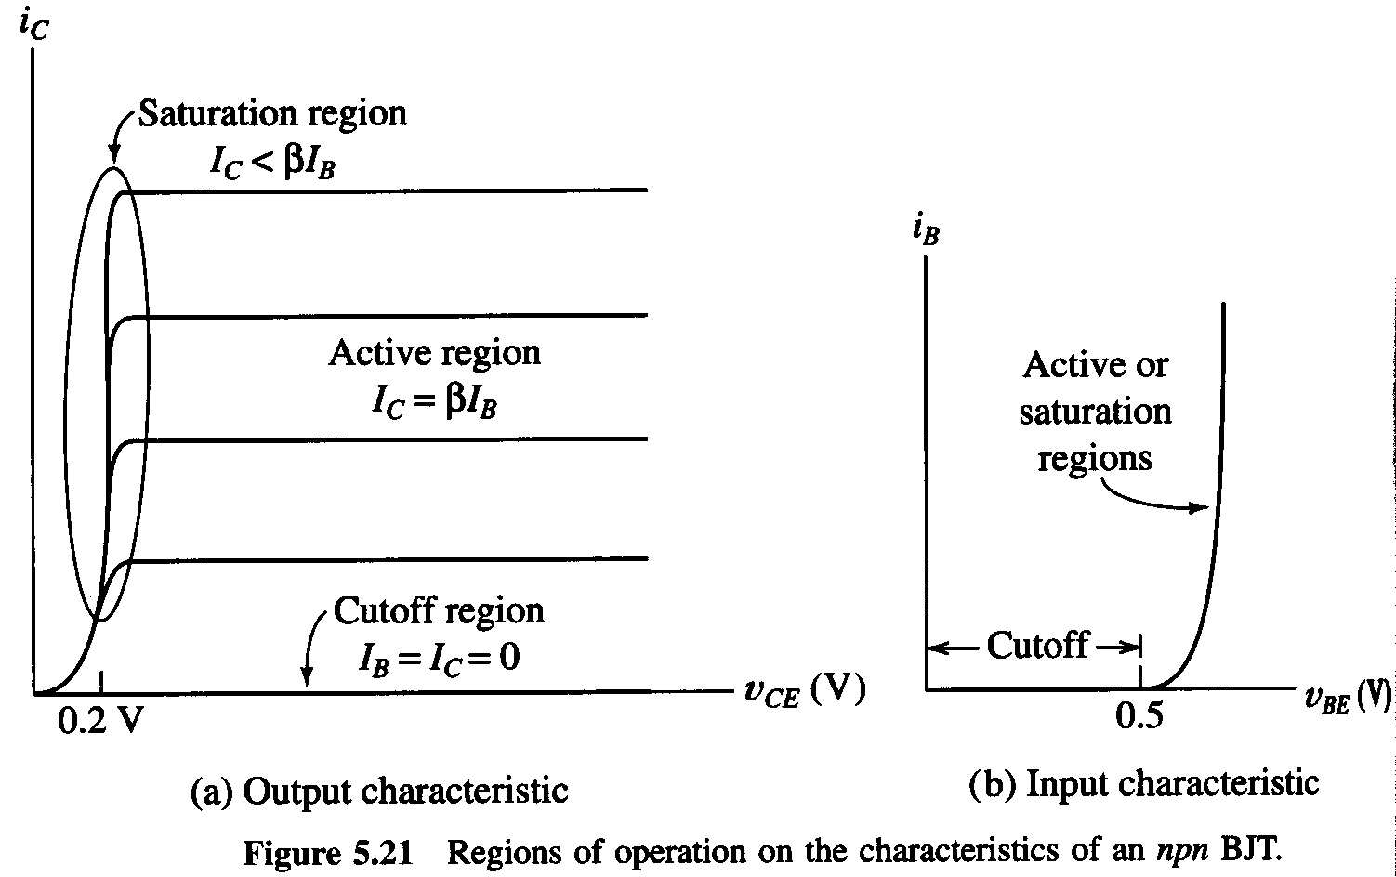

Show a plot of iC, as a function of vCE, with iB as a parameter.

Look at the transistor characteristic curves. We can identify the different regions of operation.

Now, let us idealize these characteristic curves, and see how we will model the transistor.
Cutoff - open circuits
Saturation - constant voltage sources
Active - dependent source

The Phoenician says:
The percentage of charge carriers injected by the emitter into the base, and swept into the collector, is almost 100%. We name this parameter alpha, α, and define it as

α = iC / iE

Typically α is in the range of 0.90 to 0.997 or so. It is close to 1, but less than 1.

Clearly, if iC ≈ iE, then iB must be pretty small in comparison. We define another parameter, ß, as

ß = iC / iB.

As it turns out, ß gets used even more than alpha. This is a commonly used figure of merit for a transistor. The values of α and ß are dependent; you can use KCL to derive that:

ß = α / (1 - α) .

These parameters are frequency dependent, although sometimes we ignore this. They are also temperature dependent, but we sometimes can ignore this, too.

End of 15th lecture

DC Analysis of Transistor Circuits

We often need to be able to find the dc conditions at the terminals of a BJT in a circuit. A primary application for this is in the analysis and design of dc bias conditions. We do the dc analysis with the same algorithm that was used in dc diode problems: guess, then test.
To do this we need to have rules to use. The rules that we will use, for this course, for dc analysis follow.
====================================
Active region or Linear region:

be jct is forward biased
bc jct is reverse biased

IC = ß IB = α IE ≈ IE

For npn: For pnp:
VBE = 0.7[V] VEB = 0.7[V]
IB & IC enter IB & IC leave
IE leaves IE enters

Saturation region:

be jct forward biased
bc jct forward biased

IC / IB < ß

For npn: For pnp:
VBE = 0.7[V] VEB = 0.7[V]
VCE = VCESAT VEC = VECSAT
IB & IC enter IB & IC leave
IE leaves IE enters

where VCESAT and VECSAT are parameters which will be given for these problems, for this class. Typically they are in the range of 0.1[V] to 0.4[V]. The Hambley text assumes that they are 0.2[V].

Cutoff Region:

be jct reverse biased
bc jct reverse biased

IC = IB = IE = 0.
====================================
This can also be expressed as equivalent circuits. These equivalent circuits are given in Fig. 5.20 in the Hambley text:
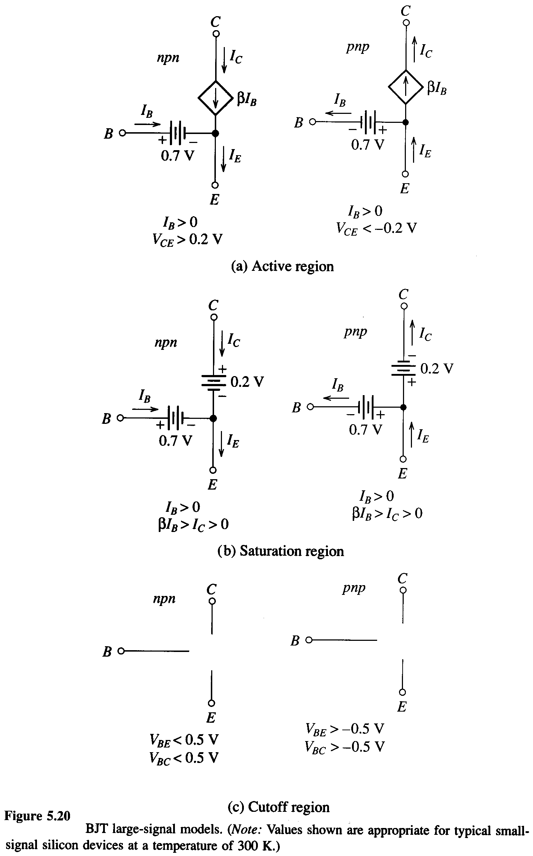

Do some example problems. Assume ß = 100.

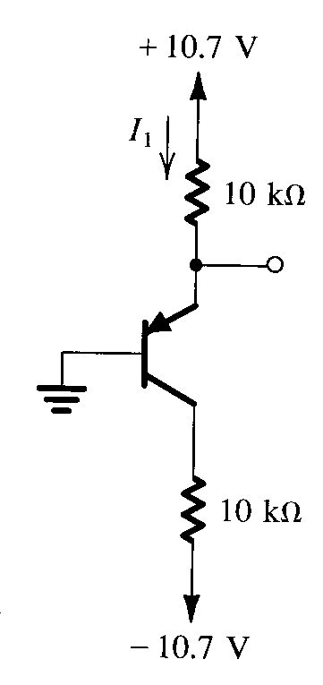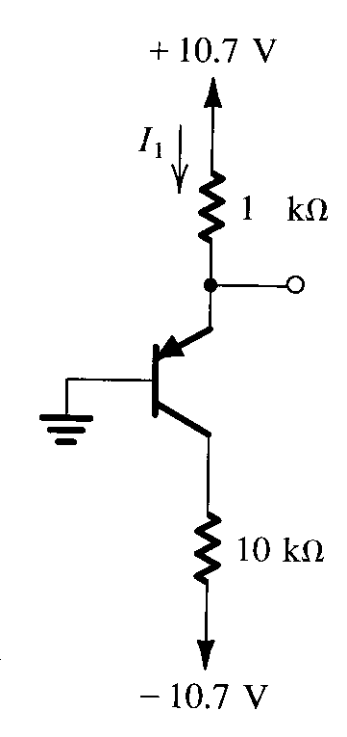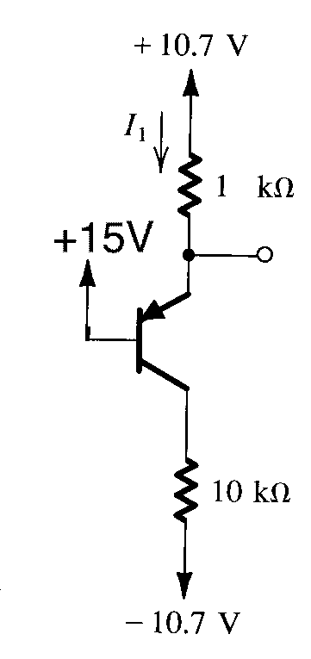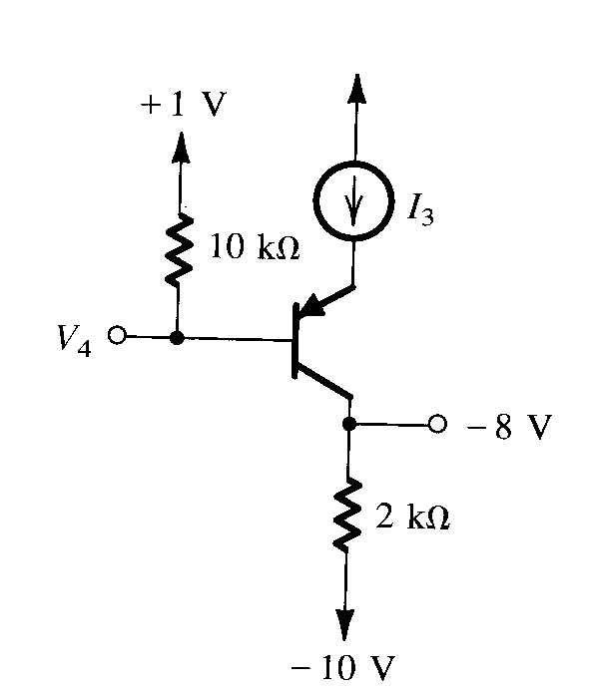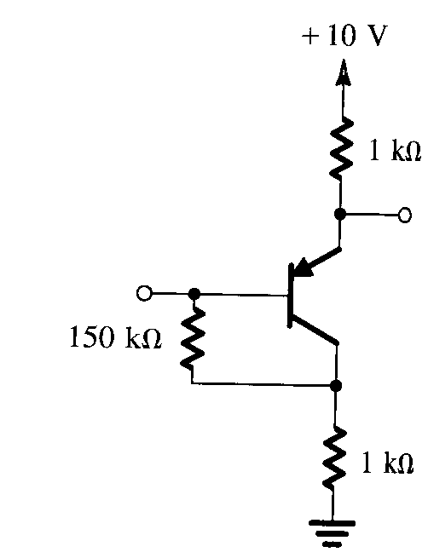

Typically, simple circuits use a voltage divider at base to set the dc bias conditions. It is usually a good idea to take the Thevenin equivalent of these circuits, with respect to ground, and use that to solve. Show how this works.

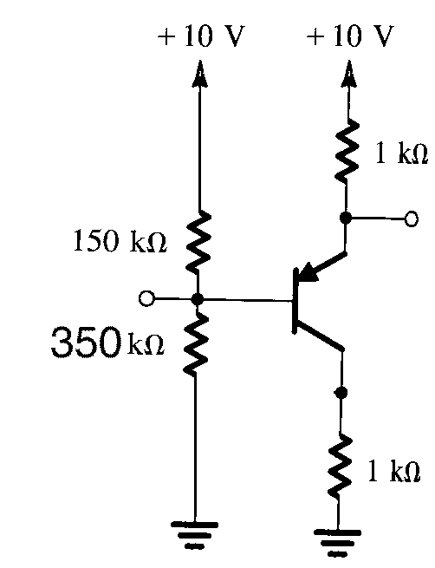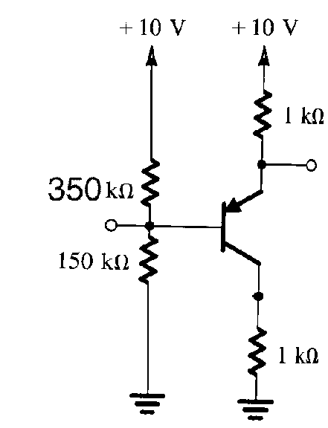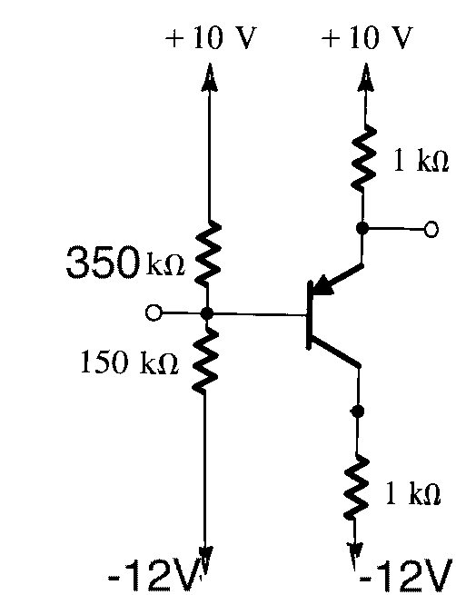
Here are some more circuits that you can play with. They are taken from the Sedra and Smith book, Microelectronic Circuits.
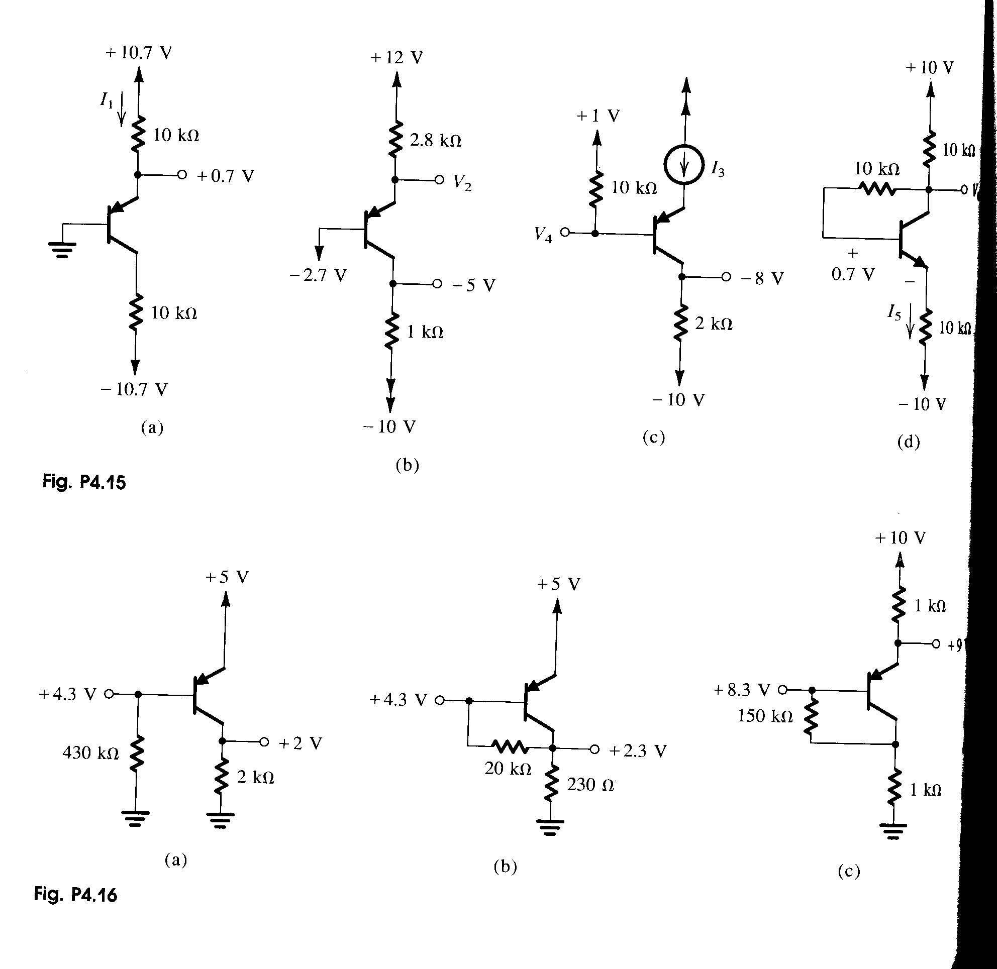
Many students have trouble with saturation at this point. (This is the saturation region of the transistor that I am speaking of, although many students feel saturated themselves, as well.) They have trouble understanding how the criterion

IC / IB < ß

comes about. They also have trouble understanding how IC can be positive if the bc junction is forward biased. The following experiment may be of benefit. Assume the simple circuit below. Assume that IS is zero, or negative, and then is increased slowly.

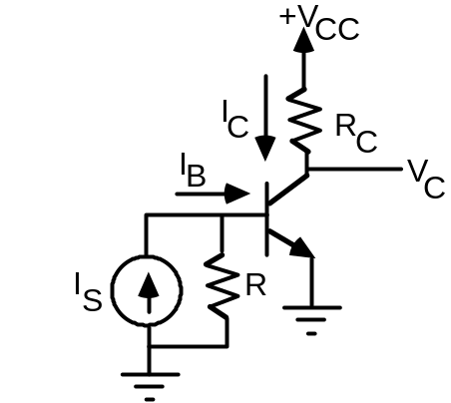
Let's start by plotting IB as a function of IS. Note that IS needs to reach a high enough value so that the b-e junction will turn on, at 0.7[V]. This corresponds to a current of
(IS )R = 0.7[V], or
IS = 0.7[V]/R.
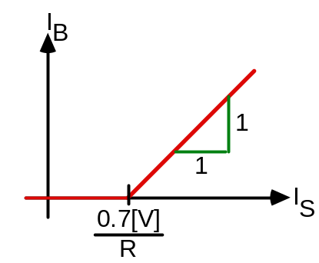
Next, let us consider the collector current IC as a function of IS. Now, when the base current IB is zero, so is the collector current. The collector current turns on at the same time as the base current, but increases with a slope of ß due to the current gain of the device.
However, while IB can increase without any limit (except Fuses' Law), IC is limited. Note that as IC increases, the voltage across RC increases, so the voltage VC decreases. However, VC will not go below VCESAT.
Question: Why not?
Answer: Because current does not flow uphill. If VC were less than VE, current would flow out of the collector, which would mean flowing out of ground and up to a higher potential. This does not happen.
Thus, IC saturates, or stops increasing. This is why we call the region saturation.
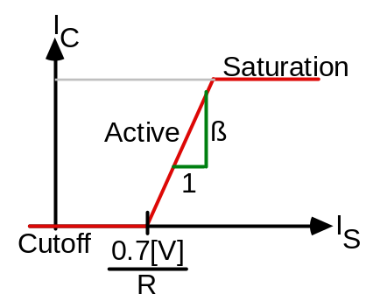
The saturation value of IC is

ICSAT = (VCC - VCESAT ) / RC .

Note that this value is not a strong function of the transistor characteristics. That is, the value of the current that saturates a transistor is mostly determined by the other circuit quantities (VCC, RC). When we say that the transistor saturates, it might be more appropriate to say that the circuit saturates, since it is mostly a function of the circuit.

End of 17th
lecture

